- Copyright for test papers and marking guides remains with West Australian Test Papers.
- The papers may only be reproduced within the purchasing school according to the advertised conditions of sale.
- Test papers must be withdrawn after use and stored securely in the school until 16th June.

PHYSICS
UNIT 3
2022

MARKING GUIDE

TIME ALLOWED FOR THIS PAPER

Reading time before commencing work: Ten minutes
Working time for the paper: Three hours

MATERIALS REQUIRED/RECOMMENDED FOR THIS PAPER

To be provided by the supervisor:
- This Question/Answer Booklet; Formula and Constants sheet

To be provided by the candidate:
- Standard items: pens, pencils, eraser or correction fluid, ruler, highlighter.

- Special items: Calculators satisfying the conditions set by the SCSA for this subject.

IMPORTANT NOTE TO CANDIDATES
No other items may be taken into the examination room. It is your responsibility to ensure that you do not have any unauthorised notes or other items of a non-personal nature in the examination room. If you have any unauthorised material with you, hand it to the supervisor before reading any further.

Structure of this paper

Section | Number of questions available | Number of questions to be answered | Suggested working time  (minutes) | Marks available | Percentage of exam
Section One:  Short answer | 11 | 11 | 50 | 54 | 30
Section Two:  Extended answer | 6 | 6 | 90 | 90 | 50
Section Three:  Comprehension  and data analysis | 2 | 2 | 40 | 36 | 20
 |  |  | Total | 180 | 100

Instructions to candidates

- The rules for the conduct of Western Australian external examinations are detailed in the Year 11 Information Handbook 2022. Sitting this examination implies that you agree to abide by these rules.

- Write your answers in this Question/Answer Booklet.

- When calculating numerical answers, show your working or reasoning clearly. Give final answers to three significant figures and include appropriate units where applicable.

When estimating numerical answers, show your working or reasoning clearly. Give final answers to a maximum of two significant figures and include appropriate units where applicable.

- You must be careful to confine your responses to the specific questions asked and follow any instructions that are specific to a particular question.

- Spare pages are included at the end of this booklet. They can be used for planning your responses and/or as additional space if required to continue an answer.
  - Planning: If you use the spare pages for planning, indicate this clearly.
  - Continuing an answer: If you need to use the space to continue an answer, indicate in the original answer space where the answer is continued, i.e. give the page number. Refer to the question(s) where you are continuing your work.

Section One: Short Response 30% (54 Marks)

Suggested working time for this section is 50 minutes.

Question 1 (4 marks)

Element | Description | Marks
uses Kepler’s law | $${\left(\frac{T^{2}}{R^{3}}\right)}_{G}={\left(\frac{T^{2}}{R^{3}}\right)}_{C}=\frac{4π^{2}}{GM}$$ | 1
rearranges Kepler’s law correctly for radius of Ganymede $R_{G}$ | $${\left(\frac{T^{2}}{R^{3}}\right)}_{G}={\left(\frac{T^{2}}{R^{3}}\right)}_{C}=\frac{4π^{2}}{GM}$$  $$R_{G}=\sqrt[3]{\frac{T_{g}^{2}R_{C}^{3}}{T_{C}^{2}}}$$ | 1
Substitute correct values (either days or seconds) | $$R_{G}=\sqrt[3]{\frac{{\left(6.195×{10}^{5}\right)}^{2}{\left(1.88×{10}^{9}\right)}^{3}}{{\left(1.469×{10}^{6}\right)}^{2}}}$$  $$R_{G}=\sqrt[3]{\frac{{\left(7.17\right)}^{2}{\left(1.88×{10}^{9}\right)}^{3}}{{\left(17.0\right)}^{2}}}$$ | 1
Determines orbital radius | $$R_{G}=1.06×{10}^{6} km$$ | 1
 | Total | 4

Question 2 (6 marks)

(a) Determine the magnitude of the induced current flowing in the loop ABCD. (3 marks)

Element | Description | Marks
Use of emf formula including resistance of section AB | $$ε=vBL=IR$$  $$I=\frac{vBL}{R}$$ | 1
Substitute correct values to calculate current | $$I=\frac{2.50×{10}^{-2}×8.55×{10}^{-1}×0.50}{1.30×{10}^{-2}}$$ | 1
Calculates correct current | $$I=0.822 A$$ | 1
 | Total | 3

(b) Identify the direction of the induced current through the resistor (section AB) and indicate with an arrow on the diagram. (1 mark)

Element | Description | Marks
Draws correct arrow on diagram | Arrow pointing down from A to B ↓ | 1
 | Total | 1

(c) With reference to Faraday’s law and the flux within the loop ABCD, explain why the current in the loop is constant. (2 marks)

Description | Marks
The velocity of the loop of wire is constant, hence experiences a constant (negative) change in flux within the coil. | 1
Since current and emf are proportional to the rate of change of flux, the induced current is constant. | 1
Total | 2

Question 3 (3 marks)

Element | Description | Marks
Sum torques about the edge of the bench. | $$Στ=0$$  or  $$τ_{cw}=τ_{acw}$$ | 1
Substitutes correct distance from edge and uses correct values | $$W_{d}×x=W_{t}×r_{t}$$  $$0.290×9.8×x=0.370×9.8×(37-54/2)$$ | 1
Calculates correct unknown distance | $$x=12.8 cm$$ | 1
 | Total | 3

Question 4 (7 marks)

(a) Determine the gradient for the graph above and, using a relevant formula, determine the strength of the magnetic field in the generator. Give your answers to a maximum of two significant figures. (3 marks)

Element | Description | Marks
Calculates correct gradient and gives gradient to max of 2 SF. | $$m=\frac{30-2}{19-1}×{10}^{-3}=1.6×{10}^{-3}$$  accept values $m=(1.5-1.6)×{10}^{-3}$ | 1
Equates gradient using formula and calculates B correctly | $$ε=2πBNAf$$  $$m=2πBNA$$  $$∴B=\frac{m}{2πNA}$$ | 1
Calculates correct magnetic field strength and gives answer to max of 2 SF. | $$B=\frac{0.00155}{2π×15×0.08×0.06}=3.4×{10}^{-3} T$$ | 1
 | Total | 3

(b) Using the vertical error bars on the graph, use a suitable method to estimate the uncertainty in the magnetic field strength. Give your magnetic field strength to two significant figures and your uncertainty to one significant figure. (4 marks)

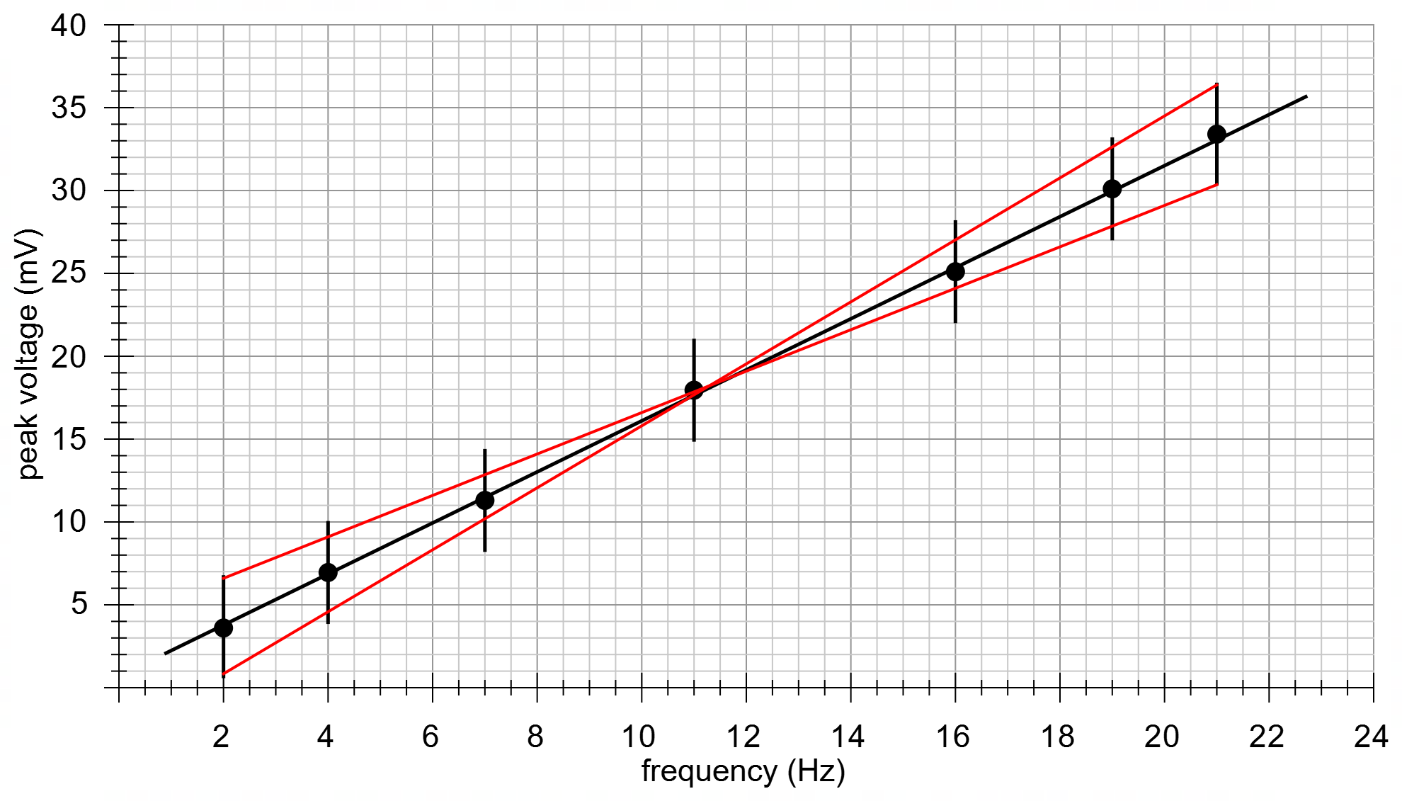

Element | Description | Marks
Uses error bars to determine a max and min gradient | $$m_{min}=\frac{30-7}{21-2}×{10}^{-3}=1.21×{10}^{-3}$$  $$m_{max}=\frac{36-1}{21-2}×{10}^{-3}=1.84×{10}^{-3}$$ | 1
calculates percentage uncertainty in gradient (or min/max B fields) | $$\%∆m=0.5×\frac{(1.84-1.21)}{1.55}×100=20.4\%$$ | 1
calculates uncertainty in magnetic field | $$∆B=0.204×3.43×{10}^{-3}=6.99×{10}^{-4} T$$ | 1
expresses field to 2 SF and uncertainty to 1 SF | $$B=(3.4±0.7)×{10}^{-3} T$$  allow $B=[\left(3.3-3.5\right)±0.7])×{10}^{-3} T$ | 1
 | Total | 4

*With regard to the final 3 marks here…
*Uncertainty could also be calculated by substituting max/min gradients into B formula from part a:
$B_{min}=\frac{0.00121}{2π×15×0.08×0.06}=2.67×{10}^{-3} T$ ; $B_{max}=\frac{0.00184}{2π×15×0.08×0.06}=4.07×{10}^{-3} T$
Then, find max/min error from result obtained in part a:
Min: (3.4-2.67)x10⁻³ = 0.725x10⁻³ = 0.7x10⁻³
Max: (4.07-3.4)x10⁻³ = 0.667x10⁻³ = 0.7x10⁻³
Therefore B = (3.4 + 0.7)x10⁻³ T. This approach is equally valid and will attract full marks.
Question 5 (4 marks)

Element | Description | Marks
Derives expression for net force on boxes, using $2F$ | $$ΣF_{boxes}=2F-W_{1}-W_{2}=ma$$  $$F=\frac{ma+W_{1}+W_{2}}{2}$$ | 1
Correctly identifies the period when $2F>W$ | Force $F$ will be greatest when net force is upward, and acceleration is upwards.  This occurs during 0 – 0.6 seconds | 1
Calculates acceleration | $$a=\frac{v-u}{t}=\frac{1.2}{0.6}=2.0 m s^{-2}$$ | 1
Calculates $F$ | $$F=\frac{350×2.0+(225+125)×9.8}{2}=2.07×{10}^{3} N$$ | 1
 | Total | 4

Question 6 (4 marks)

(a) Calculate the orbital speed of the satellite in km s^{–1}. (2 marks)

Element | Description | Marks
Derives rule for $v^{2}$ from Newton’s universal law | $$v^{2}=\frac{GM}{R}=\frac{6.67×{10}^{-11}×5.97×{10}^{24}}{(6.37×{10}^{6}+3.88×{10}^{5})}$$ | 1
Calculates velocity in km/s | $$∴v=7676 m/s=7.68 km/s$$ | 1
 | Total | 2

(b) Calculate the magnitude of the acceleration experienced by the satellite in orbit. (2 marks)

Element | Description | Marks
Uses centripetal acceleration formula for $a_{c}$ substitutes correct values | $$a_{c}=\frac{v^{2}}{r}=\frac{{\left(7.68×{10}^{3}\right)}^{2}}{6.75×{10}^{6}}$$ | 1
Calculates $g$ correctly | $$a_{c}=g=8.72 m/s^{2}$$ | 1
 | Total | 2

Question 7 (4 marks)

(a) State the direction of the reaction force exerted by the ground on the fence post. (1 mark)

Description | Marks
Upwards (or vertically up) | 1
Total | 1

(b) It is noticed that when the tensions in the fence wires are increased, the force exerted by the ground on the fence post also increases. With reference to the conditions required for equilibrium, account for this observation. (3 marks)

Description | Marks
As the tensions T increase, the horizontal component of the tension S also must increase (to remain in equilibrium horizontally) | 1
This means that the tension S must increase and consequently the vertical component of tension S, pushing down on the post, will also increase | 1
Therefore, the reaction force from the ground on the post must increase to maintain equilibrium. | 1
Total | 3

Question 8 (4 marks)

A Calcium ion (Ca²⁺) travelling in an easterly direction at a speed of 1.335 x 10⁶ m/s in a magnetic field experiences a force of 2.20 × 10^{–14} N to the south. Find the magnitude and direction of magnetic field influencing the Calcium ion. Ignore any relativistic effects.

Element | Description | Marks
uses formula for force on charged particle to calculate magnetic field $B$ | $$F=qvB$$  $$B=\frac{F}{qv}$$ | 1
substitutes correct value of charge $q$ | $$q=2×1.6×{10}^{-19}=3.2×{10}^{-19}$$ | 1
calculates $B$ field | $$B=\frac{2.20×{10}^{-14}}{3.2×{10}^{-19}×1.335×{10}^{6} }=0.0515 T$$ | 1
identifies direction of $B$ | vertically upwards (or out of page) | 1
 | Total | 4

Question 9 (5 marks)

(a) Calculate the magnitude of the force exerted by particle X on particle Y. (3 marks)

Element | Description | Marks
uses Coulomb’s law and incorporates Electric constant | $$F=\frac{1}{4π\left(8.85×{10}^{-12}\right)}\frac{q_{X}.q_{Y}}{r^{2}}$$ | 1
substitutes values of charge and distance (converts to m) | $$F=(8.992×{10}^{9})\frac{7.48×{10}^{-6}×-6.12×{10}^{-9}}{{(5.30×{10}^{-3})}^{2}}$$ | 1
calculates magnitude of force | $$F=14.7 N$$
 | Total | 3

(b) What is the magnitude of the electric field strength at X due to particle Y. (2 marks)

Element | Description | Marks
uses definition of electric field strength, divides by $q_{Y}$ | $$E=\frac{F}{q_{Y}}=-\frac{14.7}{6.12×{10}^{-9}}$$ | 1
calculates magnitude of electric field | $$E=2.39×{10}^{9} N/C$$ | 1
 | Total | 2

b) What is the magnitude of the electric field strength at X due to particle Y? (2 marks)

Element | Description | Marks
uses definition of electric field strength, divides by $q_{X}$ | $$E=\frac{F}{q_{X}}=\frac{-14.7}{7.48×{10}^{-6}}$$ | 1
calculates magnitude of electric field | $$E=1.96×{10}^{6} N/C$$ | 1
 | Total | 2

Question 10 (7 marks)

(a) Demonstrate, with a suitable calculation, that the mechanic is unable to loosen the nut by simply standing on the end of the wrench. (2 marks)

Element | Description | Marks
Uses torque equation to calculate torque of mechanic | $$τ=F.r=\left(67.0×9.8\right)×0.450$$ | 1
Compares torque to required torque | $$τ=295 Nm<775 Nm$$  Hence there is insufficient torque | 1
 | Total | 2

(b) Unable to loosen the nut, the mechanic slides a long metal tube onto the end of the wrench such that the total arm length is now 1.25 m (still in a horizontal position).

(i) Explain how this will make loosening the nut easier. (2 marks)

Description | Marks
Since torque $τ=F.r$ making the radius longer will increase the torque applied | 1
And thus reduce the required force required to achieve a specific torque. | 1
Total | 2

(ii) When the mechanic stands on the wrench, starting horizontally, through what angle will the nut rotate before stopping? Assume the mechanic doesn’t slip. Also assume that there is nothing to prevent the wrench from making a complete rotation around the nut, save only the amount of available torque. (3 marks)

Element | Description | Marks
writes expression for torque when rotated by angle $θ$ using correct trig function | $$τ=r×W_{⊥}$$  $$τ=r×mg\cos{θ}$$ | 1
substitutes correct values and uses required torque of 775 Nm | $$775=1.25×67×9.8×\cos{θ}$$ | 1
correctly calculates angle | $$θ=19.2°$$ | 1
 | Total | 3

Question 11 (6 marks)

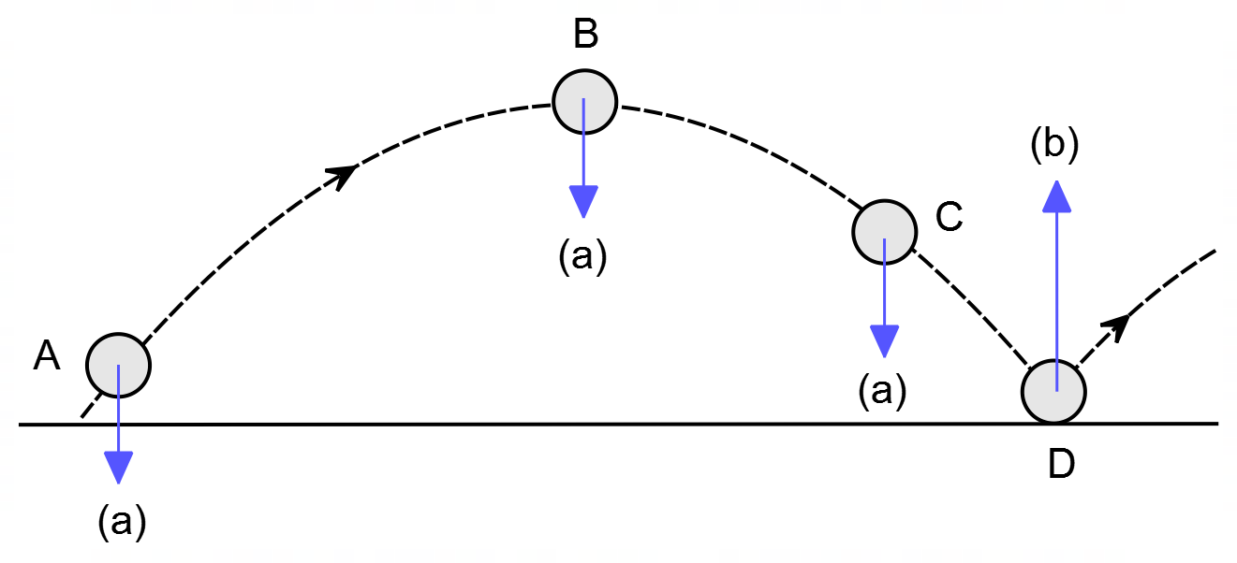

(a) On the diagram, draw a vector representing the net acceleration of the soccer ball at points A, B and C. Ignore friction and air resistance. Clearly label these vectors. (2 marks)

Description | Marks
all vertically downwards | 1
all same magnitude | 1
Total | 2

(b) On the diagram, draw a vector representing the net force on the soccer ball at point D. Ignore friction and air resistance. Clearly label this vector. (2 marks)

Description | Marks
vertically upwards | 1
greater than $g$ in magnitude | 1
Total | 2

(c) Assuming that the path of the soccer ball shown on the diagram above involves air resistance, arrange the magnitudes of the net acceleration on the ball at positions A, B and C ($a_{A}$, $a_{B}$, $a_{C}$), in the boxes below. (2 marks)

Description | Marks
$$a_{A}>a_{B}>a_{C}$$
or
$$A>B>C$$
only 1 correct | 1
all 3 correct | 1
Total | 2

Question 12 (19 marks)

The diagram below shows a proton travelling through two different electric fields; one in between the horizontal plates in the section marked ‘A’, through which the proton travels with negligible velocity, and another in between the vertical plates in the section marked ‘B’, where the plates are 20cm apart. The sphere Q is neutral, though not grounded, with a radius of 10cm; the proton passes above the sphere at a minimum distance of 4cm after leaving section ‘B’. In section ‘B’ only, there is a magnetic field keeping the proton’s path from deviating; the electric field in this space is solely there to accelerate the proton. The entire set-up is isolated from the effects of any external magnetic fields.

Q
‘A’
‘B’
20cm
4cm

X = B field,
= E field
X X X X X X X X X X X X X X X X X X X X X X X X X X X X X X X X X X X X

(a) Given that the proton passes through the electric field in section ‘A’ without deviating,
determine:

(i) The polarity of the top and bottom plates in section ‘A’: (2 marks)

Polarity of Top Plate = __Negative__ ; Polarity of Bottom Plate = ___Positive__

(ii) Draw the electric field between the plates in section ‘A’ on the diagram above: (2 marks)

Arrows pointing right way (1 mark)
Field bows at entrance (1 mark)

(ii) The magnitude of the electric field between the plates in section ‘A’: (2 marks)

$$F=Eq$$

$$F=mg$$

$$∴Eq=mg→E=\frac{mg}{q}$$
Equation = (1 mark)
$$E=\frac{(1.67×{10}^{-27})(9.8)}{(1.60×{10}^{-19})}$$

$$E=1.02×{10}^{-7} N/C$$
Solution = (1 mark)

Electric Field Strength = ____$1.02×{10}^{-7}$_____ N/C

(b) In section ‘B’, the proton experiences a force of 2.0x10⁻¹⁵ N to the right due solely to the
presence of the electric field there.

(i) Find the potential difference between the plates in section ‘B’: (2 marks)

$$E=\frac{F}{q}=\frac{2.0×{10}^{-15}}{1.6×{10}^{-19}}=12500 N/C$$
(1 mark)

$$E=\frac{V}{d}→V=Ed=12500×0.20=2500 V$$
(1 mark)

Potential Difference = _____2500________ V

(ii) Draw the electric field & the magnetic field between the plates in section ‘B’ on the
diagram above. Clearly label which is which: (2 marks)

See diagram

(ii) Find the speed of the proton at the moment when it leaves section ‘B’ (assume that the
thickness of the plates is negligible): (2 marks)

$$a=\frac{F}{m}=\frac{2.0×{10}^{-15}}{1.67×{10}^{-27}}=1.197×{10}^{12} m/s^{2}$$
(1 mark)

$$v=\sqrt{u^{2}+2as}=\sqrt{0^{2}+2(1.197×{10}^{12})(0.2)}=6.92×{10}^{5} m/s$$

(1 mark)

Speed of Proton = ____$6.92×{10}^{5}$___ m/s

Once the proton exits section ‘B’ it passes over the neutral sphere marked ‘Q’, which is connected to an external circuit, allowing it to become charged almost instantaneously. At the moment the proton passes directly above the sphere, for t = 2.89x10⁻⁷ s, the sphere gains a momentary positive charge, repelling the proton with an upward force of 2.02x10⁻¹⁵ N, causing the path of the proton to deviate.

(c) Find the magnitude of the momentary charge on the sphere ‘Q’. (2 marks)

$$F=\frac{kqQ}{r^{2}}$$
Equation = (1 mark)
$$2.02×{10}^{-15}=\frac{(9×{10}^{9})(1.6×{10}^{-19})Q}{{(0.14)}^{2}}$$

$$Q=2.75×{10}^{-8} C$$
Solution = (1 mark)

Charge on Q = ______$2.75×{10}^{-8}$_____ C

(d) Determine the final velocity of the proton. (5 marks)

$$a=\frac{F}{m}=\frac{2.02×{10}^{-15}}{1.67×{10}^{-27}}=1.21×{10}^{12} m/s^{2}$$
(1 mark)

$$v=u+at=0+\left(1.21×{10}^{12}\right)\left(2.89×{10}^{-7}\right)=3.50×{10}^{5} m/s$$
(1 mark)

v

3.50x10⁵ m/s
θ
6.92x10⁵ m/s

(1 mark)

$$v=\sqrt{{{(6.92×10}^{5})}^{2}+{{(3.50×10}^{5})}^{2}}=7.75×{10}^{5} m/s$$
(1 mark)

$$θ=\tan^{-1}{\frac{3.50}{6.92}}=26.8° from horizontal$$
(1 mark)

Velocity = ___$7.75×{10}^{5}$_____ m/s, at __$26.8°$____ ⁰ to the horizontal.

Question 13 (12 marks)

(a) On the cross-sectional view indicate the direction of the magnetic field in the coil due to the current in the coil. (2 marks)

Description | Marks
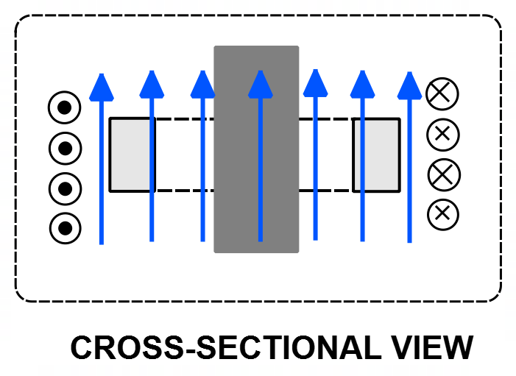
vertical | 1
approximately uniform | 1
Total | 2

(b) The cross-sectional view below shows the ring at position F. Indicate the direction of the induced current in the aluminium ring, using appropriate symbols (• and ×) for the direction of current, AND indicate the direction of the magnetic field induced in the ring due to the induced current. (2 marks)

Description | Marks
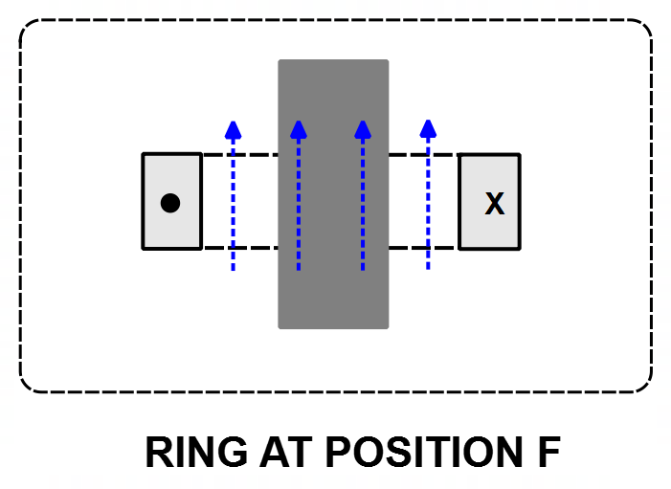
current out on left and into page on right | 1
magnetic field upwards | 1
Total | 2

(c) The first graph below shows the variation of the magnetic field experienced by the aluminium ring as the ring moves from position A to position G, along the wooden rod.

Use the information provided to sketch a graph on the set of axes below of the net force on the aluminium ring as it moves from position A to G. Use the sign convention that forces in a downward direction are negative. (5 marks)

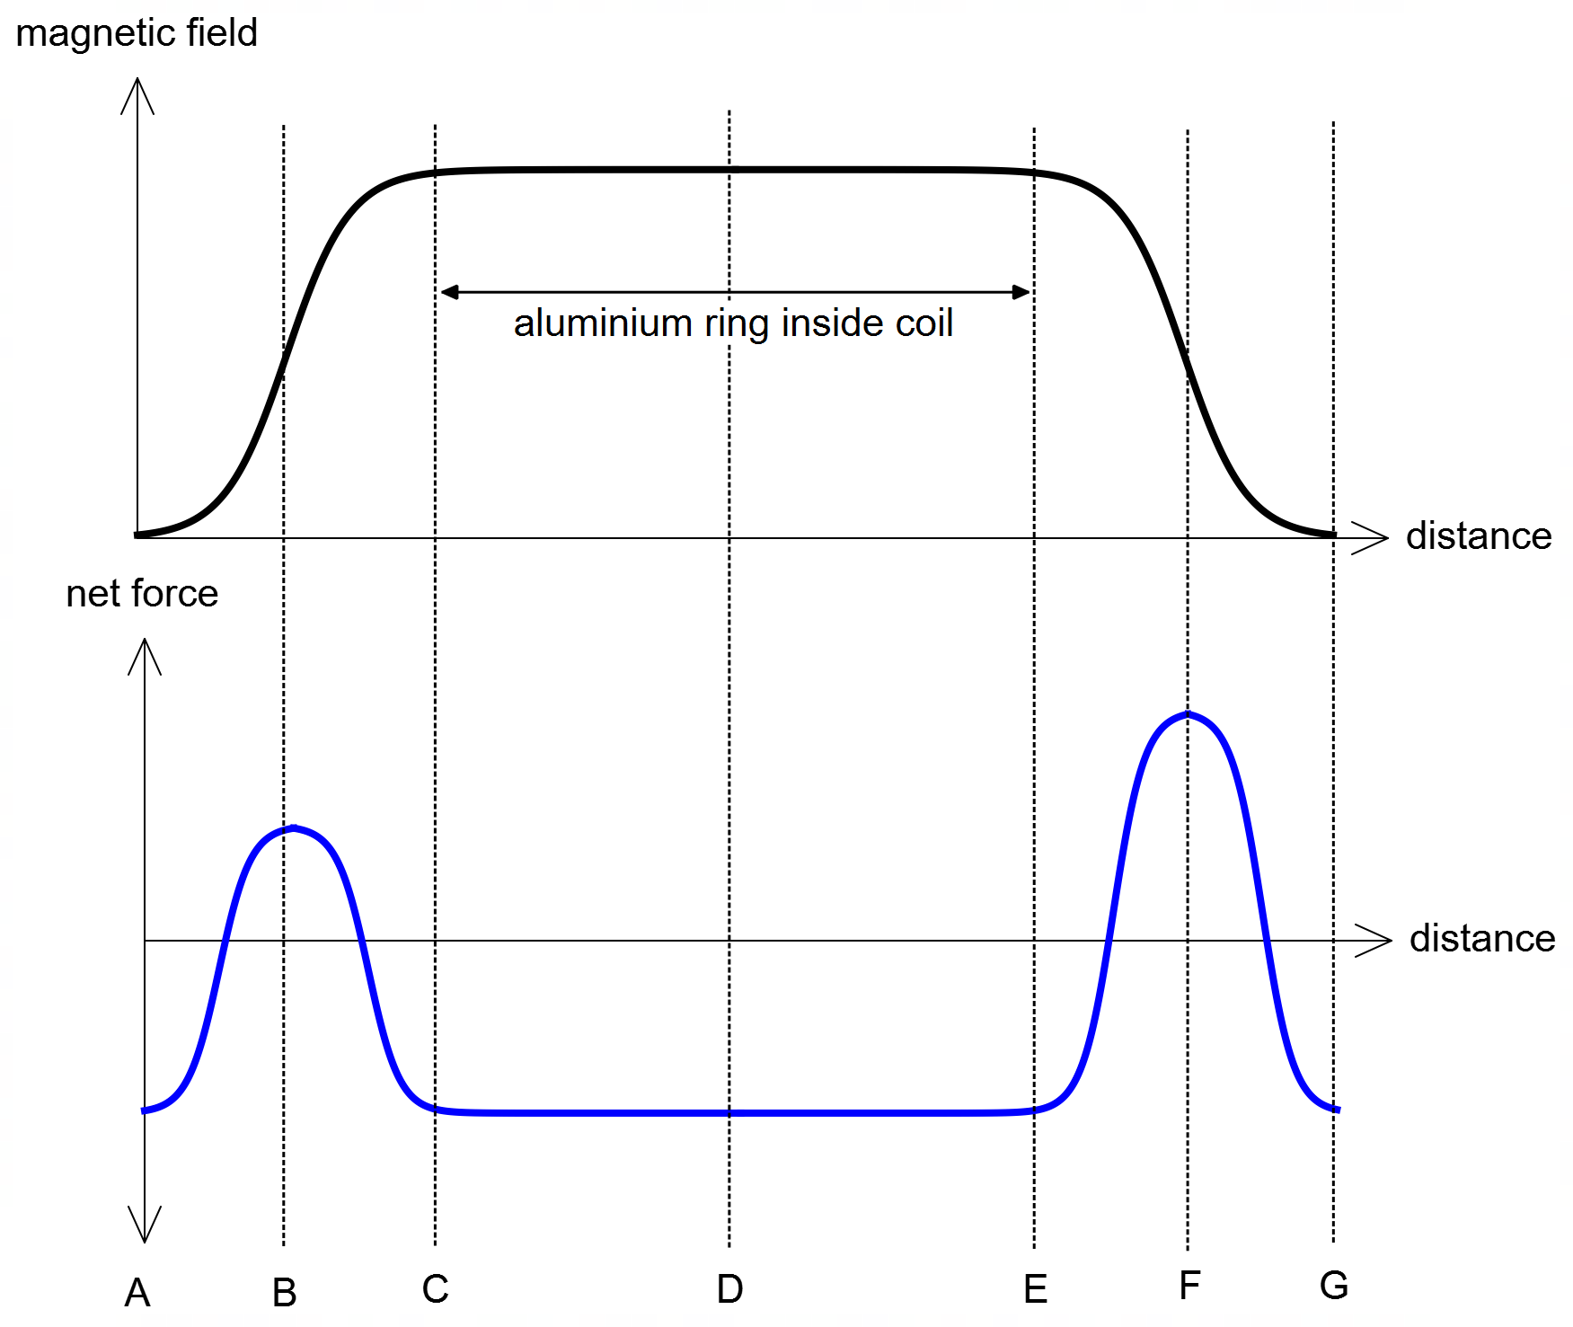

Description | Marks
constant negative force between C and E | 1
same negative value at start (A) and finish (G) positions, consistent with above | 1
symmetrical peak about B towards positive | 1
symmetrical peak about F towards positive | 1
peak at F is higher than at B | 1
Total | 5

(d) The magnetic constant for wood is 1.26 × 10^{–7} N A⁻¹ (very close to that for a vacuum) while for stainless-steel the magnetic constant is 2.10 × 10^{–4} N A⁻¹. How would using a stainless-steel rod instead of a wooden rod affect the motion of the aluminium ring as it moves from position A to G. Justify your answer with relevant physics. (3 marks)

Description | Marks
Speed through the coil would be slower (OR)  Time in the coil would be longer | 1
Since the magnetic constant for stainless-steel much higher, the magnetic field in the coil will be strengthened significantly in the rod | 1
Producing a much greater (induced current and) opposing force on the ring. | 1
Total | 3

Question 14 (14 marks)

(a) the angle to the horizontal the ball strikes the wall at point B. (5 marks)

Element | Description | Marks
calculates horizontal velocity | $$u_{x}=12.0×\cos{30°}=10.39 m/s$$ | 1
calculates vertical velocity | $$u_{y}=12.0×\sin{30°}=6.00 m/s$$ | 1
uses horizontal velocity to calculate time of flight to B | $$s_{x}=4.00=10.39×t$$  $$t=0.3849 s$$ | 1
uses relevant equation to determine vertical speed at B | $$v_{y}=u_{y}+a_{y}t=6.00+(-9.8)×0.3849$$  $$v_{y}=2.228 m/s$$ | 1
uses components and trig to determine angle to horizontal | $$\tan{θ}=\frac{v_{y}}{u_{x}}=\frac{2.228}{10.39}$$  $$θ=12.1°$$ | 1
 | Total | 5

(b) the speed of the ball as it leaves the wall at point B. (2 marks)

Element | Description | Marks
uses vertical and horizontal speeds to calculate speed | $$v=\sqrt{u_{x}^{2}+v_{y}^{2}}=\sqrt{{10.39}^{2}+{2.228}^{2}}=\sqrt{112.92}$$ | 1
calculates correct speed | $$v=10.6 m/s$$ | 1
 | Total | 2

(c) the height H of the ball at point B. (3 marks)

Element | Description | Marks
Uses $t=0.3849$ and equation of motion to calculate vertical displacement | $$s=ut+\frac{1}{2}at^{2}$$  $$s=6.00×0.3849+\frac{1}{2}(-9.8)×{\left(0.3849\right)}^{2}$$  $$s=1.583 m$$ | 1 – 2
Adds initial height | Height H is $1.583+0.90=2.48 m$ | 1
 | Total | 3

(d) the horizontal distance D the tennis player must position themselves at to hit the ball at C.
(4 marks)
EITHER
solves using quadratic approach from point A to C [or B to C]
Element | Description [alternate] |  | Marks
uses vertical drop from A to C [or B to C] and writes quadratic equation | $$s_{A}=0.30=u_{yA}t+\frac{1}{2}at^{2}$$  $$0.30=6.00.t-4.9t^{2}$$  $$0=-4.9t^{2}+6.00t-0.30$$ | $$s_{B}=-1.28=u_{yB}t+\frac{1}{2}at^{2}$$  $$-1.28=2.23.t-4.9t^{2}$$  $$0=-4.9t^{2}+2.23t+1.28$$ | 1
uses quadratic and finds time from A to C [or B to C] | $$t=\frac{-6.00±\sqrt{30.1}}{-9.8}$$  $$t=0.0522, 1.17 s$$ | $$t=\frac{-2.23±\sqrt{30.1}}{-9.8}$$  $$t=-0.332, 0.787 s$$ | 1
writes horizontal displacement with D | $$s_{x}=u_{x}.t=10.4×1.17$$  $$D+8=12.18 m$$ | $$s_{x}=u_{x}.t=10.4×0.787$$  $$D+4=8.18 m$$ | 1
calculates D | $$D=4.18 m$$ | $$D=4.18 m$$ | 1
 | Total |  | 4

OR
finds intermediate velocity at from point C [or B] to find time and distance
Element | Description [alternate] |  | Marks
uses vertical drop from A to C [or B to C] to find speed at C | $$v^{2}=u^{2}+2as$$  $$v^{2}=6^{2}+2\left(-9.8\right)\left(0.30\right)$$  $$v=-5.488 m/s$$ | $$v^{2}=u^{2}+2as$$  $$v^{2}={2.23}^{2}+2\left(-9.8\right)\left(-1.28\right)$$  $$v=-5.488 m/s$$ | 1
calculates time from A to C  [or B to C] | $$t=\frac{v-u}{a}$$  $$t=\frac{-5.49-6.00}{-9.80}=1.17 s$$ | $$t=\frac{v-u}{a}$$  $$t=\frac{-5.49-2.23}{-9.80}=0.787 s$$ | 1
uses horizontal velocity to write distance from A to C  [or B to C] | $$s_{x}=D+8.00=u_{x}.t$$  $$D+8.00=10.39×1.17$$ | $$s_{x}=D+4.00=u_{x}.t$$  $$D+4.00=10.39×0.787$$ | 1
calculates D | $$D=4.18 m$$ |  | 1
 | Total |  | 4

Question 15 (15 marks)
(a) Determine the direction of the current flowing in coil ABCD (as viewed from above) – clockwise or anticlockwise? Circle your answer. (1 mark)

Description | Marks
CLOCKWISE | 1
Total | 1

(b) Determine the maximum torque generated by the coil. (4 marks)

Element | Description | Marks
Use of the torque formula | $$τ=Fr$$  $$τ=BILr$$ | 1
Recognises $n=10$ turns and two sides of the coil | $$τ=2nBILr or τ=BIAn$$ | 1
Substitutes correct values | $$τ=2×10×0.84×2.75×0.120×(0.08/2)$$ | 1
Calculates torque | $$τ=0.222 Nm$$ | 1
 | Total | 4

(c) Spring-loaded Carbon brushes are used to connect the split ring commutator to the external power supply. Explain the two properties that are essential for the Carbon brushes to perform their function: (2 marks)

Element | Description | Marks
Explanation of conductivity | The brushes must be able to conduct electricity; as the commutator rotates, the brushes provide constant electrical contact with the external power source, allowing current to flow through the rotor. | 1
Explanation of heat/friction resistance. | The brushes will be subjected to friction as the commutator rotates, so they must be resistant to heat/friction. | 1
 | Total | 2

(d) The student decided to modify the DC motor and uses a wire of three times the original length and forms it into a similar-shaped rectangular coil as before, but with double the length of AB and double the width of BC. Determine the factor by which the torque produced in this new motor configuration is greater than in the original configuration. You may assume that all the wire is used to make the coils (i.e., ignore the wire to the commutator). (5 marks)

Element | Description | Marks
uses original length of wire $L_{1}$ calculates new length of wire $L_{2}$ | $$L_{1}=10×\left(2×0.12+2×0.08\right)=4.00 m$$  $$L_{2}=3×L_{1}=12.0 m$$ | 1
calculates new number of turns $n_{2}$ with new perimeter $P$ | $$P=2×\left(2×0.12+2×0.08\right)=0.80 m$$  $$n_{2}=\frac{L_{2}}{P_{2}}=\frac{12.0}{0.80}=15$$ | 1
substitutes correct values into torque formula | $$τ=nBAI=15×0.840×(0.24×0.16)×2.75$$ | 1
calculates torque | $$τ=1.33 Nm$$ | 1
calculates factor of increase in torque | $$\frac{1.33}{0.222}=6.00$$ | 1
 | Total | 5

(d) The student got the motor running but noticed that there was a reduction in the net voltage across the coil as it rotated. Further, the student noticed that this drop in voltage increased as the speed of the motor increased. Account for these observations using relevant physics.

Description | Marks
The wire coil spinning in a magnetic field has an included emf across the coil since the coil experiences a change in flux (according to Faraday’s Law) | 1
This emf (according to Lenz’s law) acts to oppose the applied voltage and thus reduces the net voltage in the coil | 1
The size of the induced emf is proportional to rate of change of flux and therefore the voltage-drop increases at higher speeds (*Students may refer to ‘Back EMF’ here – however, it is the explanation(s) that are important & worth marks). | 1
Total | 3

Question 16 (14 marks)

(a) Show that the tension in the rope is approximately 70 N. (5 marks)

Element | Description | Marks
Sums torques about point P | $Στ=0$OR $τ_{cw}=τ_{acw}$ | 1
Writes the torques generated by pole ($p$), flag ($f$), and rope ($r$) | $$W_{p⊥}.r_{p}+W_{f⊥}.r_{f}=T_{r⊥}.r_{r}$$ | 1
Substitutes correct values | $$\left(9.10×9.8×\sin{28°}\right)×2.10$$  $$+ \left(0.755×9.8×\sin{28°}\right)×4.20$$  $$=T_{⊥}.(2/3×4.20)$$ | 1
Correctly identifies angle and component of tension in rope | $$87.92+14.59=T.\sin{32°}×2.80$$ | 1
Correctly calculates tension | $$T=\frac{102.51}{1.484}=69.1 N$$ | 1
 | Total | 5

(b) Determine the magnitude of the reaction force and the direction relative to the horizontal, of the reaction force of the ground acting on the pivot at point P. Note: if you did not calculate part (a) you may use the value of 70 N for tension in the rope. (5 marks)

Element | Description [alternate using 70 N] | Marks
Sums hor. forces to find $R_{x}$  (Right positive) | $$ΣF_{x}=R_{x}-T_{x}=0 →R_{x}=T_{x}$$  $$R_{x}=69.1×cos{30°}=59.8 N [60.62]$$ | 1
Sums vert. forces to find $R_{y}$  (Up positive) | $$ΣF_{y}=R_{y}-W_{p}-W_{f}-T_{y}=0$$  $$R_{y}=9.8×\left(9.10+0.755\right)+69.1×\sin{30°}=131.1 N [131.6]$$ | 1 – 2
Calculates net force $R$ | $$R=\sqrt{{59.8}^{2}+{131.1}^{2}}=144 N [144.9]$$ | 1
Uses components to find $θ$ relative to horizontal | $$\tan{θ}=\frac{R_{y}}{R_{x}}=\frac{131.1}{59.8}$$  $$θ=65.5° [65.3°]$$ | 1
 | Total | 5

(c) Describe and account for how the magnitude of the tension force in the rope changes as the flagpole is raised closer to vertical. (4 marks)

Description | Marks
As the pole is raised, the radial arm for the weight of the flag and pole reduces | 1
Thus, the net CW torque produced by the flag and pole reduces | 1
Thus, less ACW torque is required for equilibrium | 1
Hence, the required tension force is less | 1
Total | 4

Question 17 (6 marks)

A motorbike and rider of combined mass 230 kg is in horizontal circular motion inside of a spherical cage, which can be modelled as horizontal circular motion on a banked track (see dotted line in diagram). The vehicle has a speed of 14.0 m s⁻¹ and is relying on friction to stay at a fixed height in the sphere. The radius of the circle is 4.0 m. The ‘track’ is banked at an angle of 65.0⁰ to the horizontal. Friction acts from the cage onto the motorbike parallel to the ‘track’ as shown.
Vector Diagram:
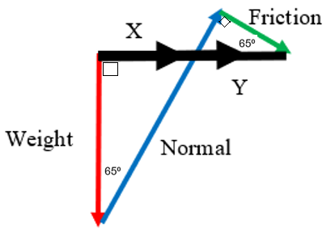
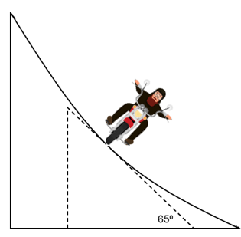
Friction

(a) Construct a vector diagram in the space provided above. Show the forces acting on the vehicle and the net force. (2 marks)

Correct vector addition (tip-to-tail) of Weight, Normal & Friction forces (1 mark)

Realising Sum of Forces needs to be segmented (into X & Y, or some other dummy variables) (1 mark)

(b) Calculate the magnitude of the friction force acting on the vehicle. (4 marks)

$$\sum{F}=F_{C}=\frac{mv^{2}}{r}=X+Y=\frac{230×{14}^{2}}{4}=11270 N$$
(1 mark)

$$X=mg×\tan{65⁰}=230×9.8×\tan{65⁰}=4833.72 N$$
(1 mark)

$$Y=\frac{mv^{2}}{r}-X=11270-4833.72=6463.28 N$$
(1 mark)

$$Friction=Y×\cos{{65}^{0}}=6463.28×\cos{{65}^{0}}=2720.1 N=2.72×{10}^{3} N$$
(1 mark)

Friction = $2.72×{10}^{3} N$

Question 18 (10 marks)

A 75.0 kg pilot is flying an aircraft around an airport while waiting to land. The pilot is flying the plane in a horizontal circular path of radius 9.00 km as shown. Each revolution about the airport takes 525 seconds to complete.

(a) Determine the magnitude of both the centripetal force and centripetal acceleration on the pilot during this horizontal flight. (4 marks)

Element | Description | Marks
calculates velocity from period and distance | $$v=\frac{2πr}{T}=\frac{2π×9000}{530}=108 m/s$$ | 1
substitutes correct values into correct formula | $$F_{c}=mv^{2}/r$$  $$F_{c}=\frac{75.0×{\left(107\right)}^{2}}{9.00×{10}^{3}}$$ | 1
calculates centripetal force | $$F_{c}=96.7 N$$ | 1
calculates centripetal accel. | $$a_{c}=\frac{F_{c}}{m}=\frac{96.7}{75.0}=1.29 m s^{-2}$$ | 1
 | Total | 4

(b) Determine the angle that the plane must bank to achieve this horizontal flight. (2 marks)

Element | Description | Marks
uses trigonometry to relate $F_{c}$ to $W$ and the angle of bank $θ$ | $$\tan{θ}=\frac{F_{c}}{W}=\frac{96.7}{75.0×9.8}$$ | 1
calculates angle $θ$ | $$θ=7.49°$$ | 1
 | Total | 2

(c) During this descent the plane speeds up to a maximum of 116 m s^{–1} at the bottom. Determine the maximum apparent weight of the pilot during this manoeuvre? (4 marks)

Element | Description | Marks
identifies the bottom of the curve as the max apparent weight and writes force equation | $$ΣF=R-W=F_{c}$$  $$R=F_{c}+W$$ | 1
writes equation for apparent weight | $$R=\frac{mv^{2}}{r}+mg$$ | 1
substitutes correct values | $$R=\frac{75.0×{(116)}^{2}}{1.30×{10}^{3}}+75.0×9.8$$ | 1
calculates apparent weight | $$R=1.51×{10}^{3} N$$ | 1
 | Total | 4

Question 19 (18 marks)

(a) Explain how the phenomenon of ‘wing effect’ increases the range of a discus. Use relevant physics concepts in your explanation. (4 marks)

Description | Marks
The ‘wing effect’ provides extra lift $L$ for the discus | 1
Therefore, the net force is reduced (or the net acceleration $a$ is smaller than $g$):  $$ΣF_{down}=mg-L=ma$$  $$a<g$$ | 1
Thus, the time taken $t$ for the discus to rise, and fall is increased | 1
Hence, the distance travelled horizontally ($s_{x}=u_{x}.t$) is increased | 1
Total | 4

(b) A certain discus throw has the following parameters: the angle of release is 37.6°, the height of release is 1.66 m, the range of the throw was measured at 69.2 m, and the release speed was 24.0 m s⁻¹. By calculating the expected range (with no air resistance) determine the ‘wing effect’, as a percentage, for this throw? (6 marks)

Element | Description | Marks
calculates component velocities | $$u_{x}=24.0×\cos{37.6°}=19.01 m/s$$  $$u_{y}=24.0×\sin{37.6°}=14.64 m/s$$ | 1
calculates final vertical speed  (uses a sign convention) | $$v^{2}=u^{2}+2as={14.64}^{2}+2\left(-9.8\right)\left(-1.66\right)$$  $$v=-15.72 m/s$$ | 1
calculates time of flight | $$t=\frac{v-u}{a}=\frac{-15.72-14.64}{-9.8}=3.098 s$$ | 1
calculates horizontal distance | $$s_{x}=u_{x}.t=19.01×3.098=58.90 m$$ | 1
compares distances as a ratio | $$\frac{69.2}{58.90}=1.175$$ | 1
expresses ‘wing effect’ | An increase of $17.5\%$ | 1
 | Total | 6

(c) Estimate the maximum tension in the arm of an Olympic female discus thrower during her throw. Give your answer to an appropriate number of significant figures. Clearly state your assumptions. (4 marks)

Element | Description | Marks
extracts data from text (mass and time)  makes valid assumption about radius | assumptions:  $m=1.00 kg$ (text, par. 3)  $t=1.0 s$, $rotations=1.5$ (text, par. 5)  assume $r=0.75 m$  $0.5 m<r<1.25 m$ (text, fig. 1) | 1
estimates release speed  (initial speed is zero) | $$v_{av}=\frac{d}{t}=\frac{1.5×2π×0.75}{1.0}=\frac{u+v}{2}=\frac{0+v}{2}$$  $$→v=14 m/s [9.4-24]$$ | 1
uses centripetal force to determine tension $T$ | $$T=\frac{mv^{2}}{r}=\frac{1.00×{14}^{2}}{0.75}=266$$ | 1
calculates tension $T$ to max 1 or 2 SF | $$T=270 N [71-720]$$ | 1
 | Total | 4

(d) The discus below is travelling upwards and has an angle of attack of 10°. On the discus below draw and label the forces acting on the discus. In the dashed box draw a vector diagram, including the net force. Assume that this discus is uniform. (4 marks)

Element | Description | Marks
Draws lift, weight, and air resistance forces on the discus.  The lift force needs to be clearly off perpendicular (as per questions) | 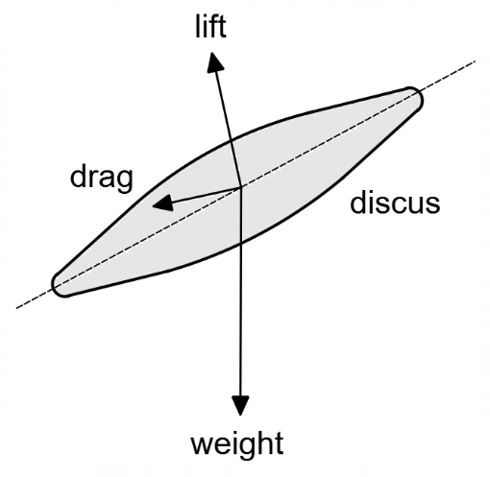 | 1 – 2
Draws correct vector diagram heat-to-tail, including net force | 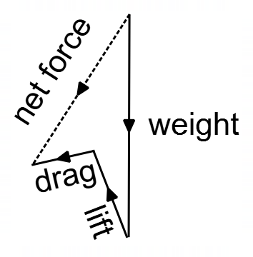 | 1 – 2
 | Total | 4

Question 20 (18 marks)

(a) List one economic advantage and one environmental disadvantage of wind turbines.
(2 marks)

Element | Description | Marks
Economic advantage | Low operating costs | 1
Environmental disadvantage | Winds are not always constant/sufficient  OR  Visual and/or noise impact | 1
 | Total | 2

(b) The peak current flowing in a 1.5 MW turbine is 105 A, the strength of the magnetic field is 2.25 T, the coils consist of 315 turns of wire and are formed in a 30.0 cm by 42.0 cm rectangle. Using this information, show that the average power of this turbine is approximately 1.5 MW. (5 marks)

Element | Description | Marks
calculates the induced emf in the coil | $$ε=2πNBAf$$ | 1
substitutes correct values | $$ε=2π×315×2.25×(0.300×0.42)×50$$ | 1
calculates emf | $$ε=28055 V$$ | 1
uses average power formula from text | $$P_{avg}=\frac{1}{2}V_{p}I_{p}$$  $$P_{avg}=0.5×28055×105$$ | 1
calculates power | $$P_{avg}=1.47×{10}^{6} W=1.47 MW$$ | 1
 | Total | 5

(c) Using Betz’s law, calculate the maximum power which can be extracted from a 1.5 MW wind turbine in winds speeds of 40.0 km h⁻¹ (the density of air is 1.225 kg m⁻³). (4 marks)

Element | Description | Marks
identifies correct data | $$ρ=1.225 kg/m^{3}$$  $$v=40/3.6=11.1 m/s$$  $$d=78.0 m$$ | 1
calculates area of rotors | $$A=πr^{2}=π×{39.0}^{2}=4778 m^{2}$$ | 1
substitutes values | $$P_{B}=\frac{8}{27}ρv^{3}A=P_{B}=\frac{8}{27}×1.225×{(11.1)}^{3}×4778$$ | 1
calculates average power available | $$P_{B}=2.38×{10}^{6} W=2.38 MW$$ | 1
 | Total | 4

(d) Using your answer to part (b) and (c) calculate the utility factor of a 1.5 MW wind turbine. (Note: if you didn’t calculate part (b) and/or (c) you may use an average power of 1.5 MW and an available power of 2.4 MW). (1 mark)

Element | Description | Marks
uses definition of utility factor | $$\frac{P_{avg}}{P_{B}}=\frac{1.47}{2.38}=0.618 [0.625]$$ | 1
 | Total | 1

(e) A simplified free-body diagram of the forces acting on the nacelle and rotor assembly is shown below. By taking torques about a suitable point, calculate the location of point X (the Centre of Gravity for the nacelle and rotor assembly) in relation to the centre line of the tower. Explain what this means in relation to the stability of the assembly. Assume that the reaction force R acts through point X. (6 marks)

Element | Description | Marks
free body diagram | 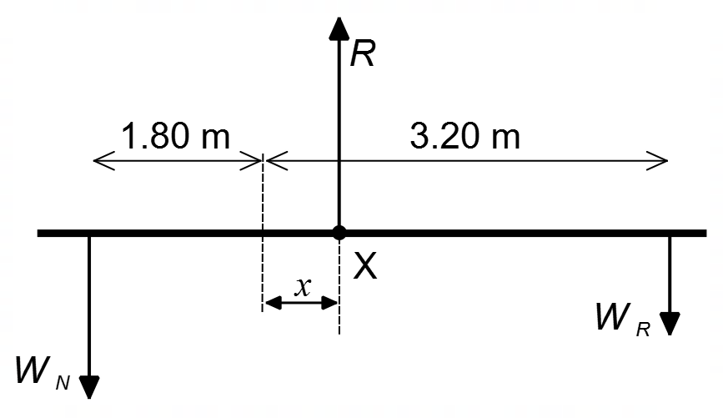
writes torque equation about point X | $$τ_{CW}=τ_{ACW}$$  $$W_{R}\left(3.20-x\right)=W_{N}(1.80+x)$$ | 1
uses correct distances and forces in torque equation | $$\left(25.0×{10}^{3}×9.8\right)\left(3.20-x\right)$$  $$=(42.0×{10}^{3}×9.8)(1.80+x)$$ | 1
ignores reaction force $R$ | Ignores reaction force $R$ | 1
solves for $x$ | $$7.84×{10}^{5}-2.45×{10}^{5}x=7.4088×{10}^{5}+4.116×{10}^{5}x$$  $$43120=656600x$$  $$x=0.0657 m$$ | 1
compares $x$ to the width of the tower | point X is only 6.6 cm away from the centreline and well within the tower radius of 1.10 m | 1
explains stability | since the CoG is within the base, the top assembly is stable and in equilibrium. | 1
 | Total | 6

